**Microservices**

**Creating Microservices for account and loan**

In this hands on exercises, we will create two microservices for a bank. One microservice for handing accounts and one for handling loans.

Each microservice will be a specific independent Spring RESTful Webservice maven project having it's own pom.xml. The only difference is that, instead of having both account and loan as a single application, it is split into two different applications. These webservices will be a simple service without any backend connectivity.

**IMPLEMENTATION :**

LoanApplication.java

package com.cognizant.loan;

import org.springframework.boot.SpringApplication;

import org.springframework.boot.autoconfigure.SpringBootApplication;

@SpringBootApplication

public class LoanApplication {

public static void main(String[] args) {

SpringApplication.run(LoanApplication.class, args);

}

}

LoanController.java

package com.cognizant.loan.controller;

import org.springframework.web.bind.annotation.*;

import java.util.Map;

@RestController

@RequestMapping("/loans")

public class LoanController {

@GetMapping("/{number}")

public Map<String, Object> getLoanDetails(@PathVariable String number) {

return Map.of(

"number", number,

"type", "car",

"loan", 400000,

"emi", 3258,

"tenure", 18

);

}

}

application.properties

server.port=8081

LoanApplicationTests.java

package com.cognizant.loan;

import org.junit.jupiter.api.Test;

import org.springframework.boot.test.context.SpringBootTest;

@SpringBootTest

class LoanApplicationTests {

@Test

void contextLoads() {

}

}

gitignore

target/

*.log

*.class

.idea/

*.iml

gitattributes

* text=auto

HELP.md

# Loan Microservice

This microservice exposes a dummy REST API for retrieving loan details.

mvnw

#!/bin/sh

# Simulated mvnw script

echo "Running Maven Wrapper..."

mvnw.cmd

@echo off

REM Simulated mvnw.cmd script

echo Running Maven Wrapper...

pom.xml

<project xmlns="http://maven.apache.org/POM/4.0.0"

xmlns:xsi="http://www.w3.org/2001/XMLSchema-instance"

xsi:schemaLocation="http://maven.apache.org/POM/4.0.0 http://maven.apache.org/xsd/maven-4.0.0.xsd">

<modelVersion>4.0.0</modelVersion>

<groupId>com.cognizant</groupId>

<artifactId>loan</artifactId>

<version>0.0.1-SNAPSHOT</version>

<name>loan</name>

<description>Loan Microservice</description>

<properties>

<java.version>11</java.version>

</properties>

<dependencies>

<dependency>

<groupId>org.springframework.boot</groupId>

<artifactId>spring-boot-starter-web</artifactId>

</dependency>

<dependency>

<groupId>org.springframework.boot</groupId>

<artifactId>spring-boot-devtools</artifactId>

<scope>runtime</scope>

</dependency>

<dependency>

<groupId>org.springframework.boot</groupId>

<artifactId>spring-boot-starter-test</artifactId>

<scope>test</scope>

</dependency>

</dependencies>

<build>

<plugins>

<plugin>

<groupId>org.springframework.boot</groupId>

<artifactId>spring-boot-maven-plugin</artifactId>

</plugin>

</plugins>

</build>

</project>

**OUTPUT :**

**Account :**

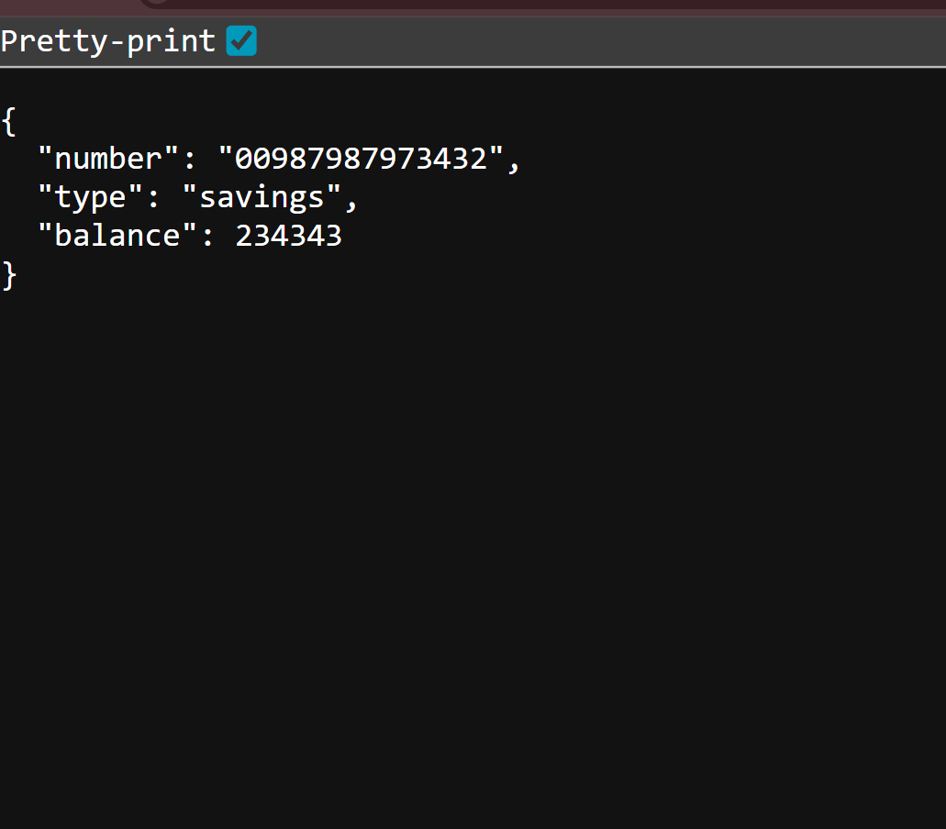

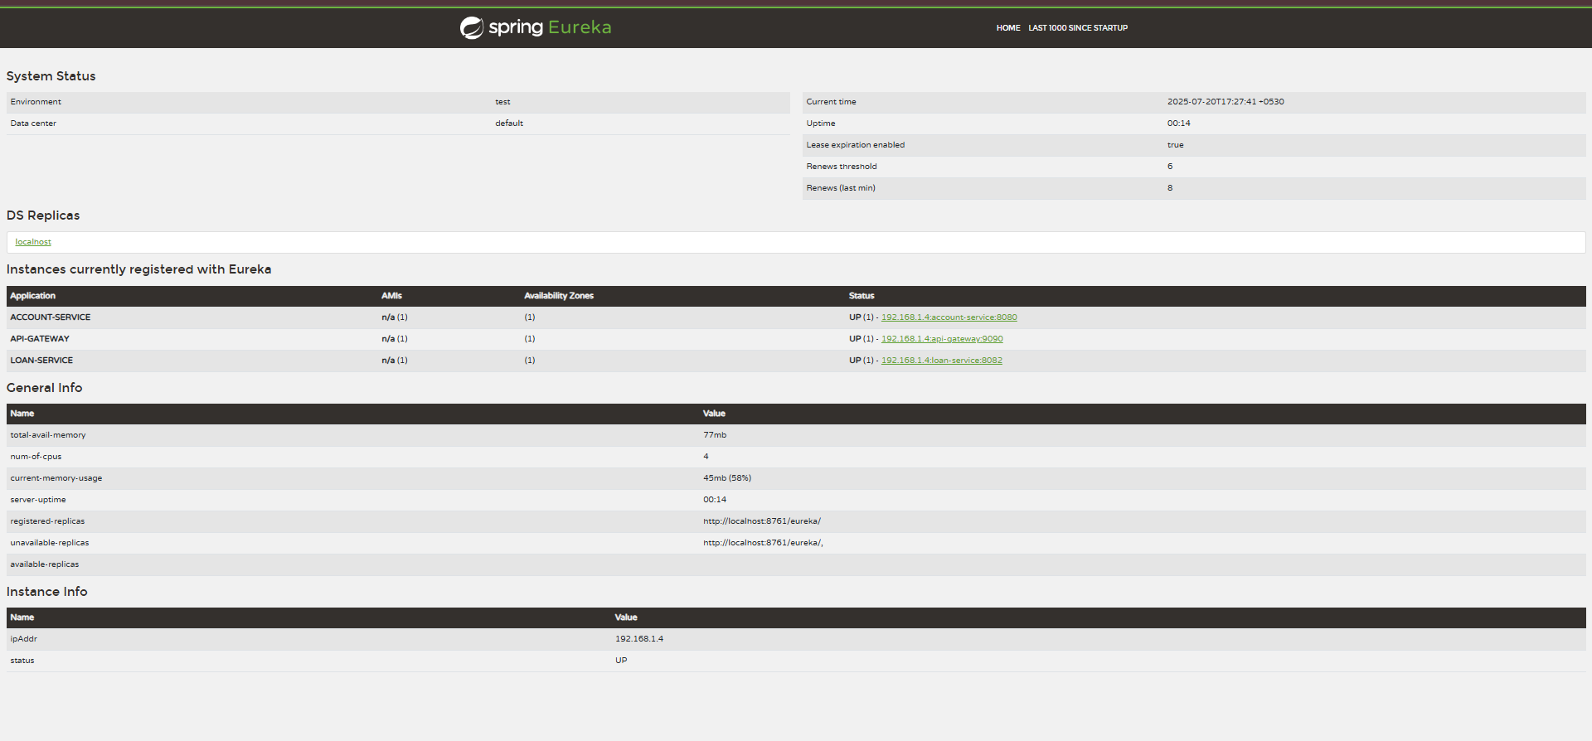

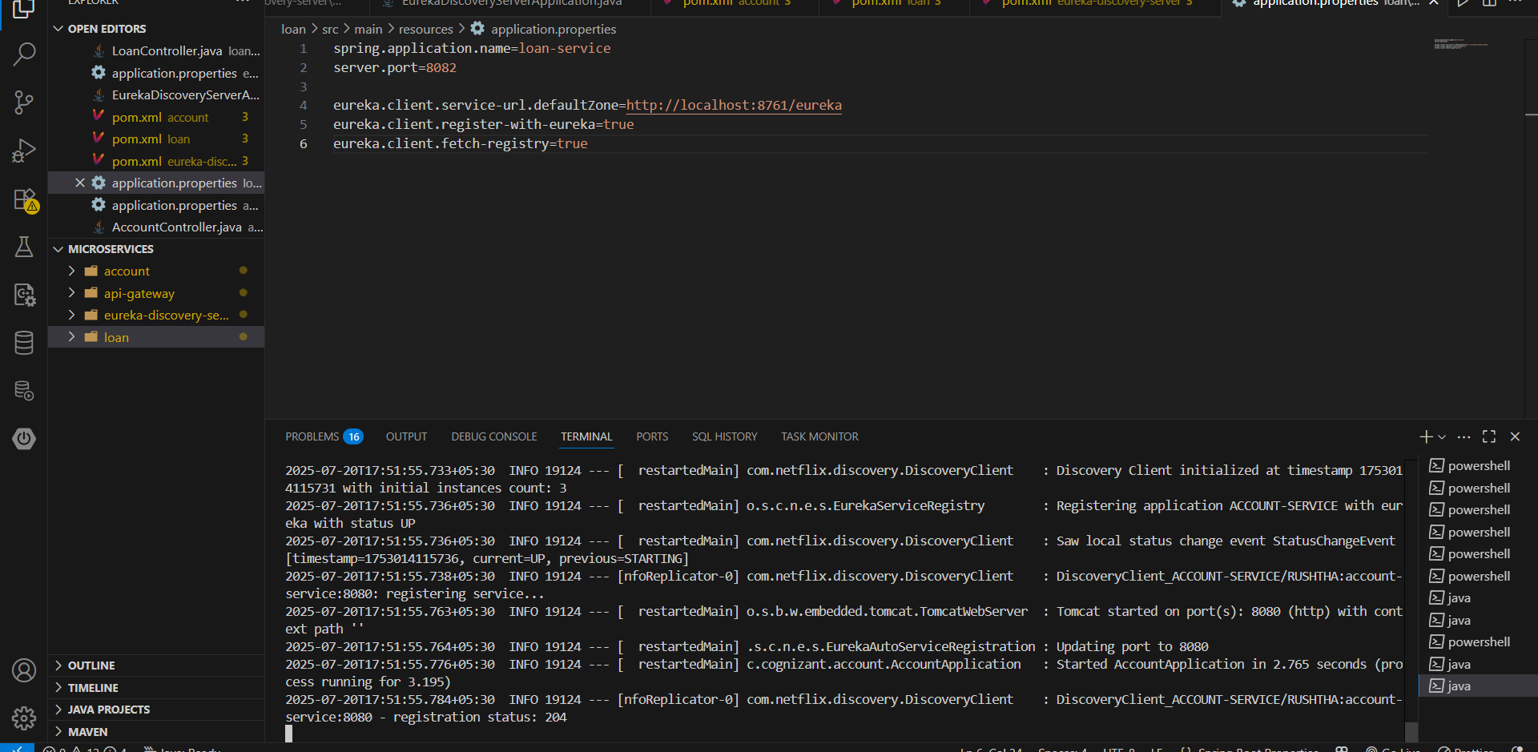

**Loan :**

